Nama : Aswangga Bhanu Rizqullah

Kelas : 5 A / Kelompok 3

HomeWork Week 7

Case 1

Module Rumus.js

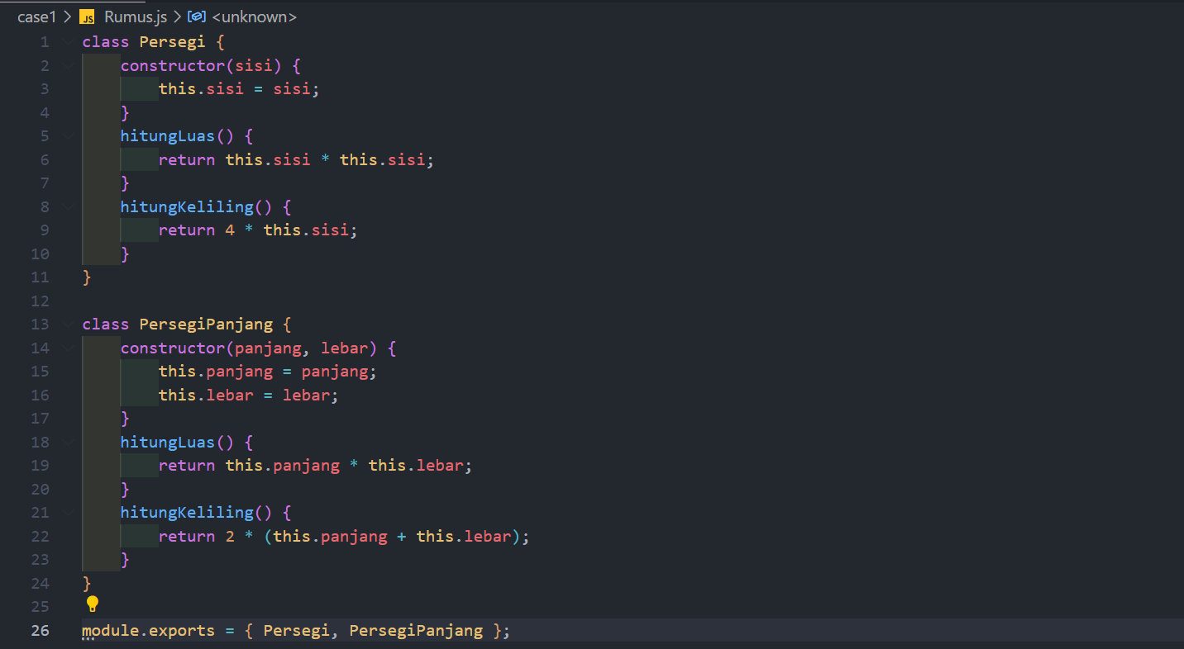

Soal1.js

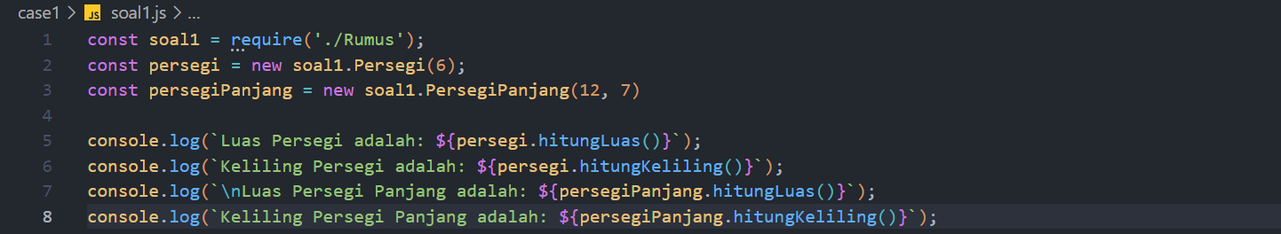

Case 2

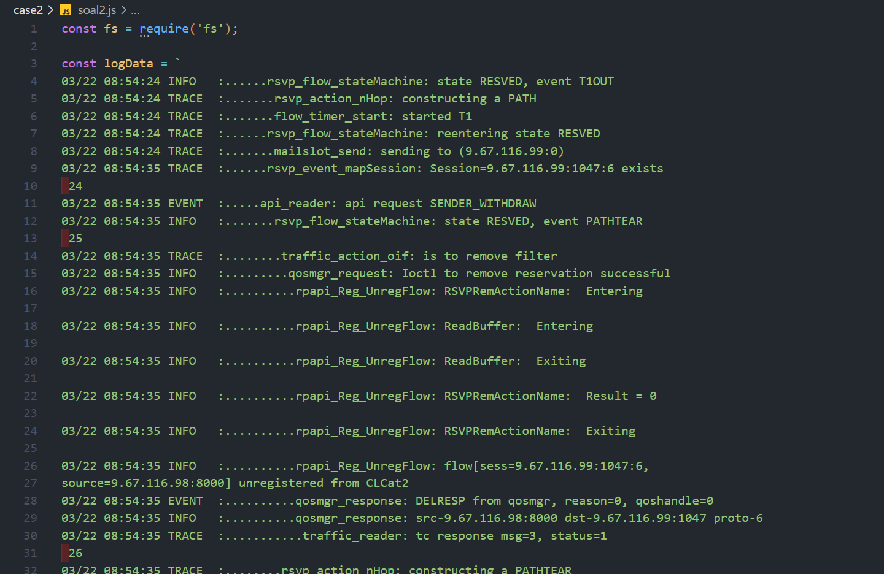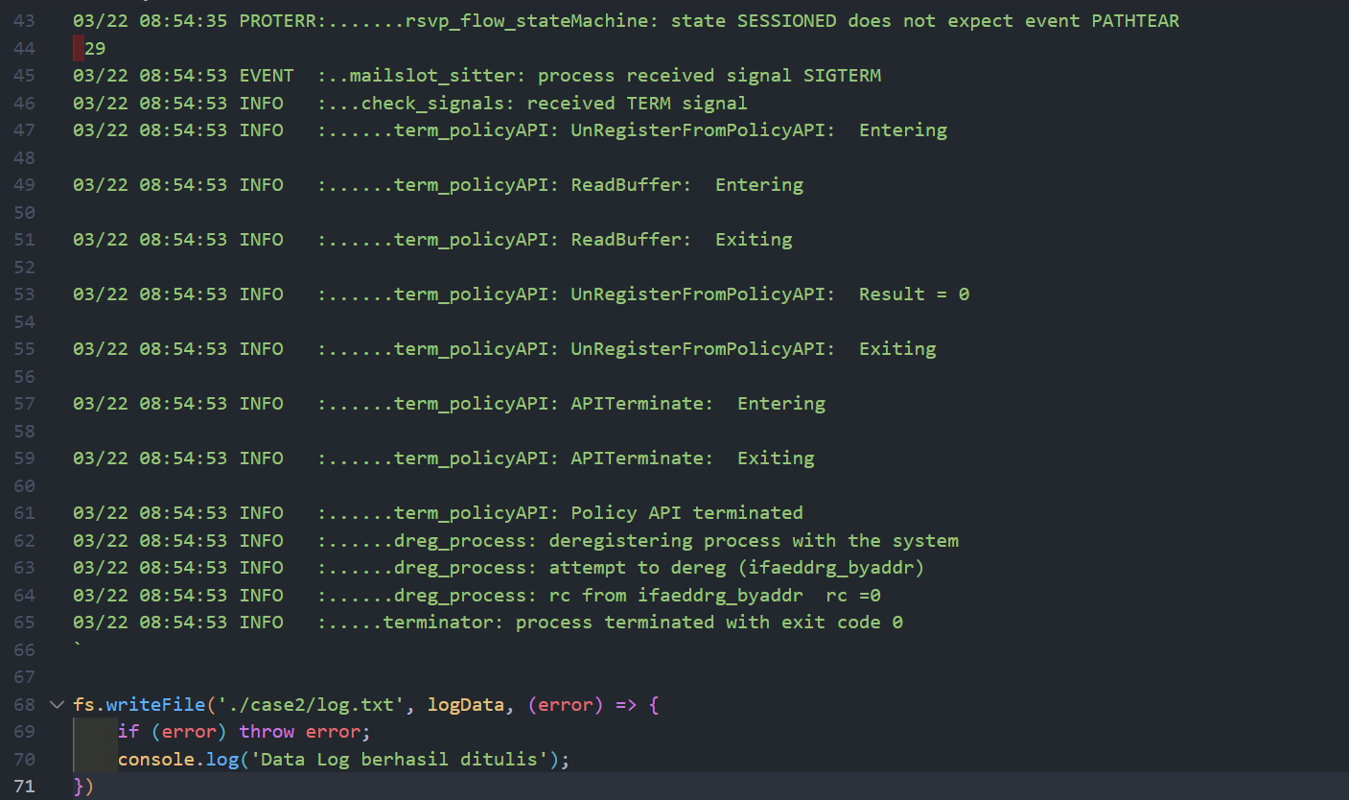

Log.txt

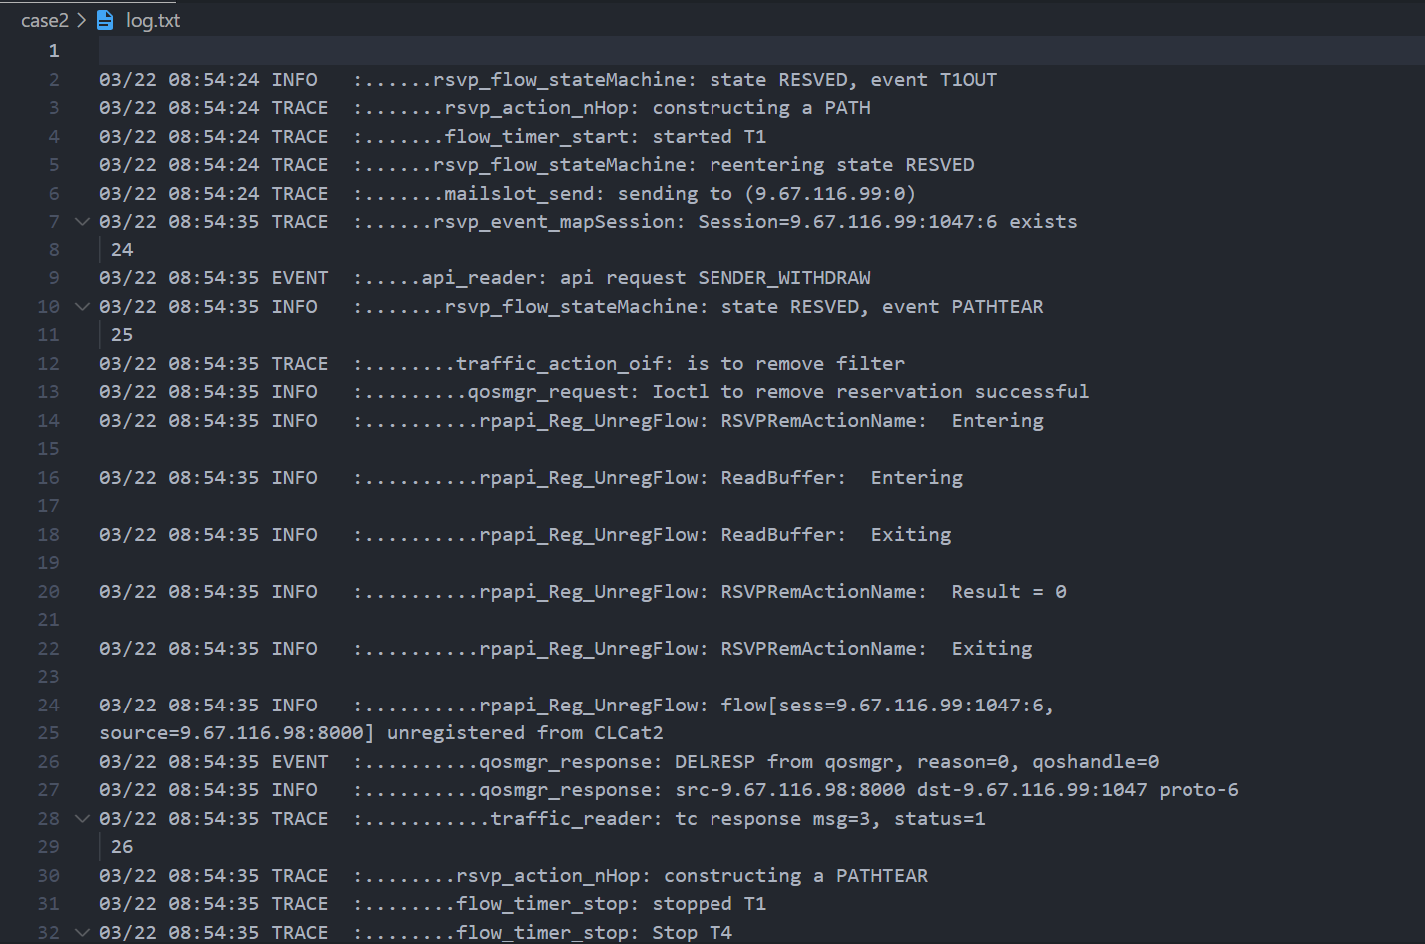

Link file repo github

<https://github.com/Bhanurzh/RakaminFSWD/tree/main/HW7>